**WORKSHEET # 1**

**Objetivo:** Consolidar conocimientos previos.

**Instrucciones:** Completa esta guía y envíala a [miss.mili.mr@gmail.com](mailto:miss.mili.mr@gmail.com)

**1. Find the following colors. Color.**

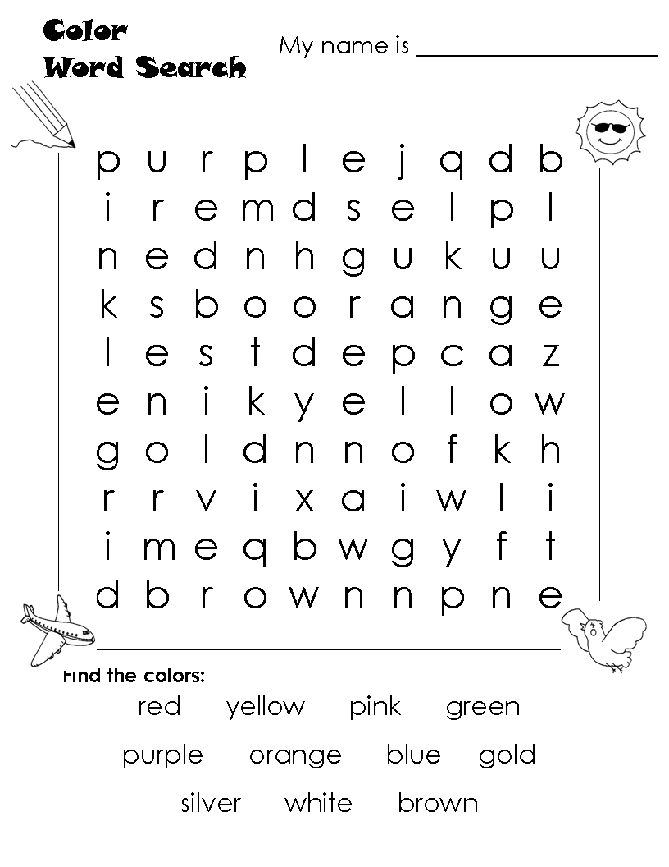

RED YELLOW PINK GREEN

   

PURPLE ORANGE BLUE BROWN

   

WHITE SILVER GOLD

  

**2. Solve. Use words.**

FIVE + FIVE = TEN

1. EIGHT + TWO = ____________________ 2. SEVEN + TWO = ____________________

3. NINE + FOUR = ____________________ 4. TEN + TEN = ____________________

5. ONE + FOURTEEN = ____________________ 6. SEVEN + TWO = ____________________

7. EIGHTEEN - THREE= ____________________ 8. ELEVEN - SIX = ____________________

**3. Count and write the number.**

___2__ hens.

______ sheep.

______ ducks.

______ pigs

______ rabbits.

______ cows.

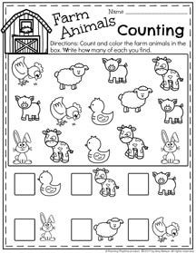



**DO YOUR BEST!!**