**WORKSHEET # 1**

**Objetivo:** Consolidar conocimientos previos.

**Instrucciones:** Completa esta guía y envíala a miss.mili.mr@gmail.com

**I. Write these numbers.**

Ten = _ **10**___

a. Twenty= ________ b. Forty = _________ c. Fifty = ________

d. Ninety = ________ e. One hundred = ________ f. Sixty = ________

g. Thirty = ________ h. Eighty = ________ i. Seventy = ________

**II. Circle.**

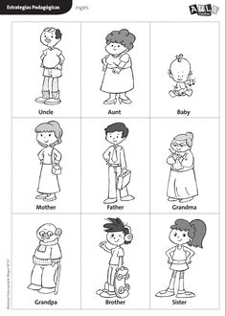     

AUNT MOM BABY BABY UNCLE AUNT

GRANDAD GRANDMA UNCLE DAD AUNT UNCLE

  

GRANDAD BROTHER BABY

GRANDMA DAD SISTER

**III. Read and match.**

She likes listening to music.

He likes watching TV.

He enjoys playing football.

He doesn’t like drinking juice.

She enjoys reading.

He doesn’t like playing football.

She doesn’t enjoy washing the car.

 

 

 