**WORKSHEET # 1**

**Objetivo:** Consolidar conocimientos previos.

**Instrucciones:** Completa esta guía y envíala a miss.mili.mr@gmail.com

**I. Choose the correct alternative**

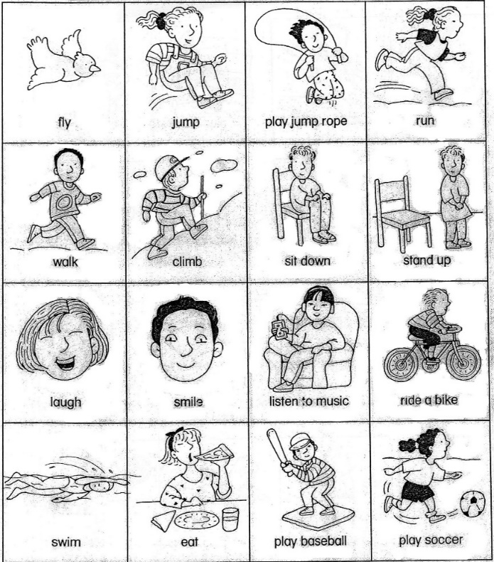 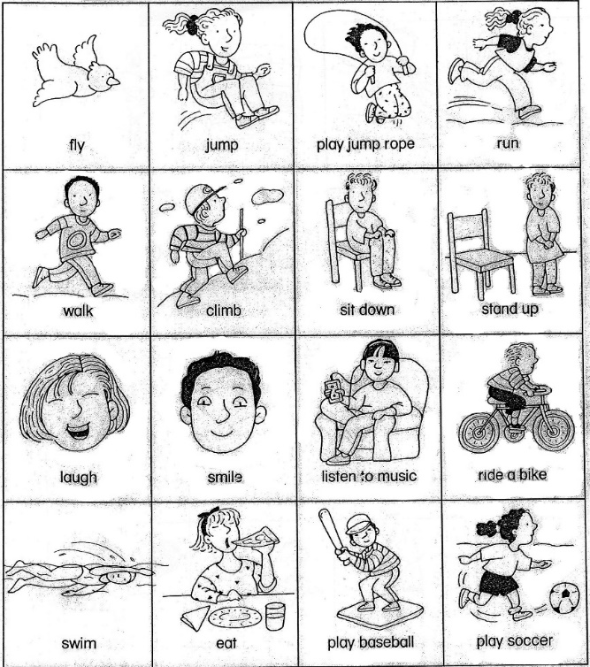 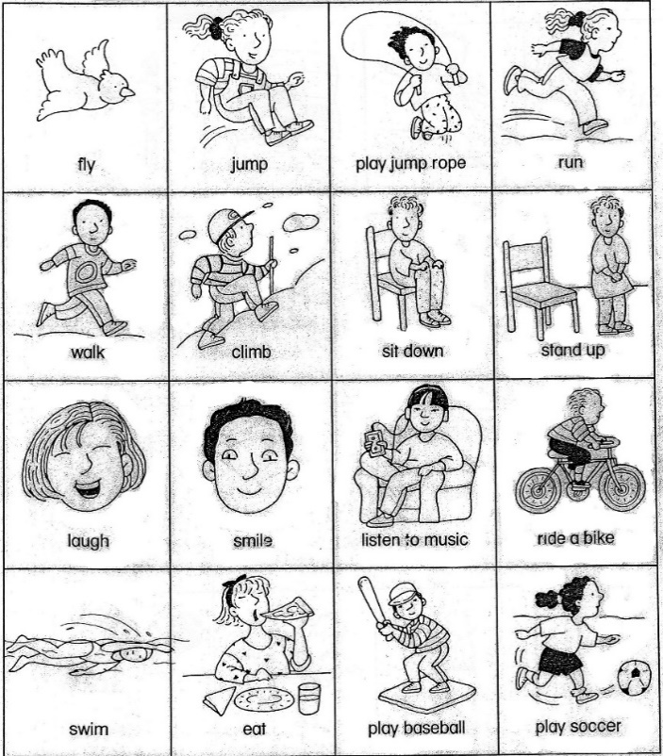 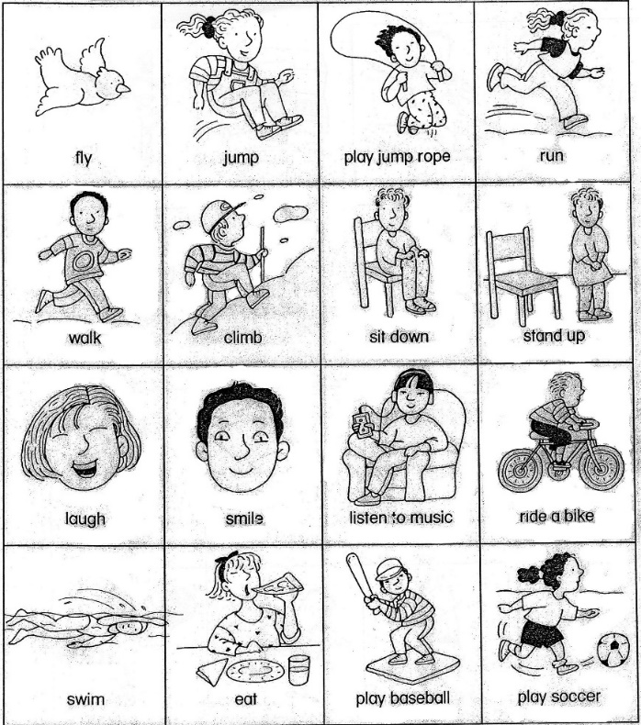 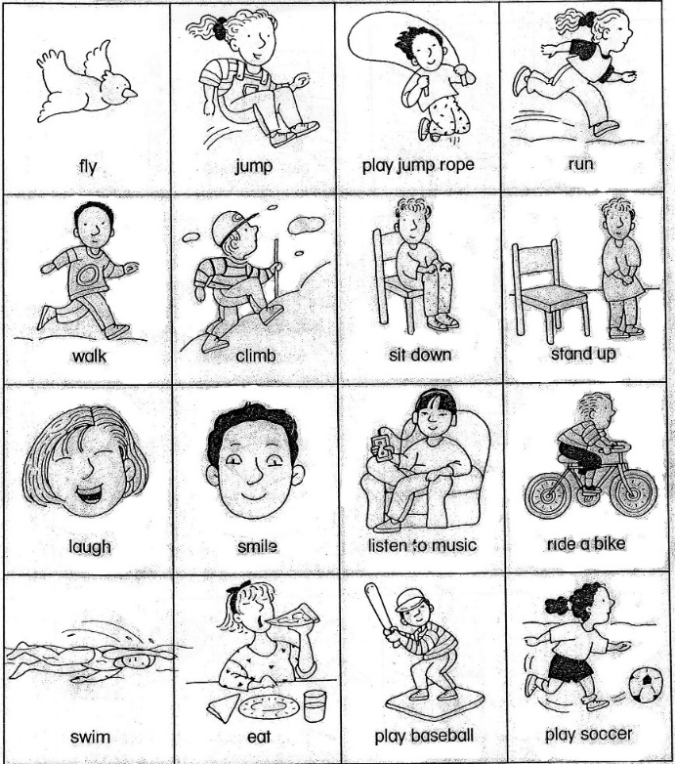 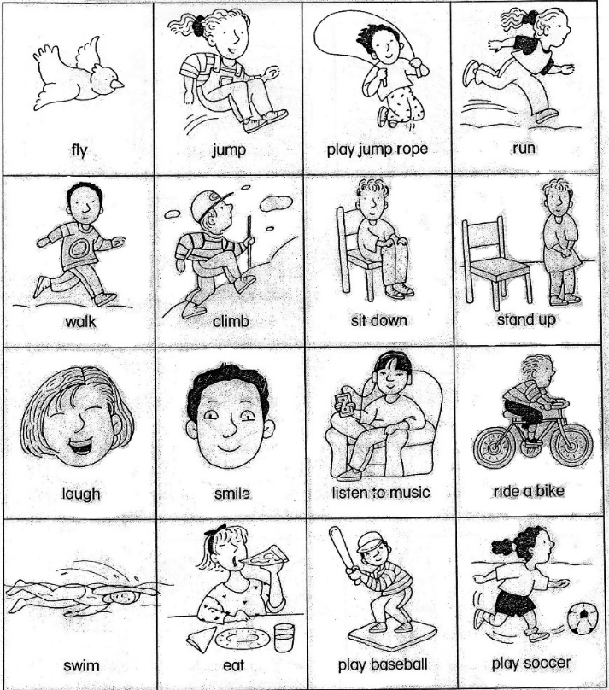 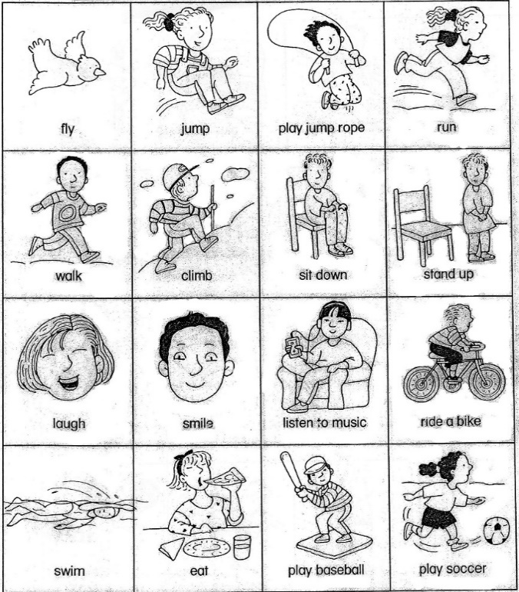

Sit Down Sit Down Run Walk Jump Listen To Music Eat

Stand Up Stand Up Climb Skip Climb Brush My Teeth Drink

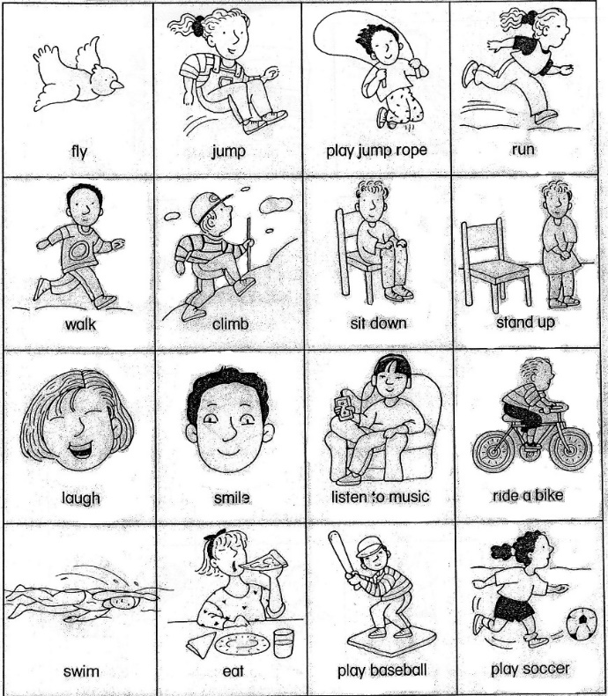 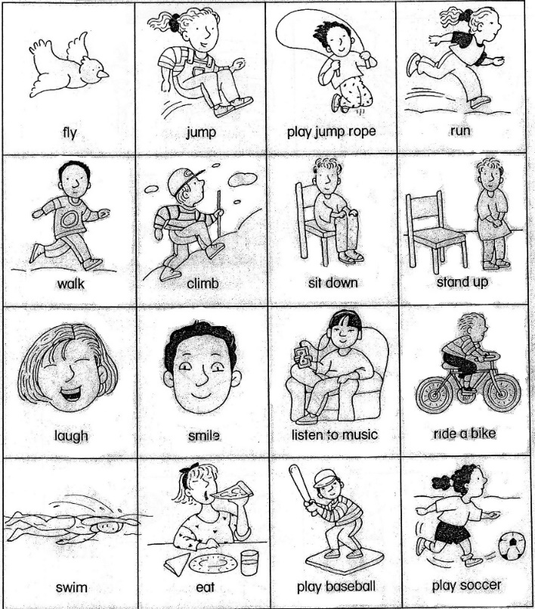 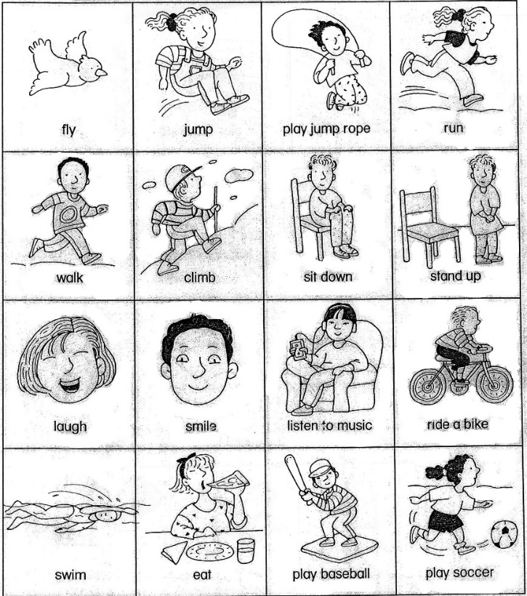 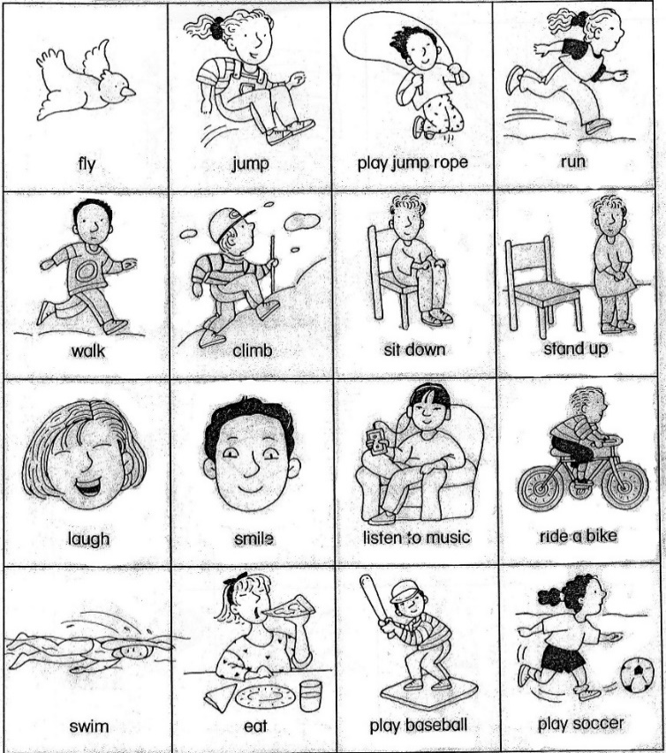 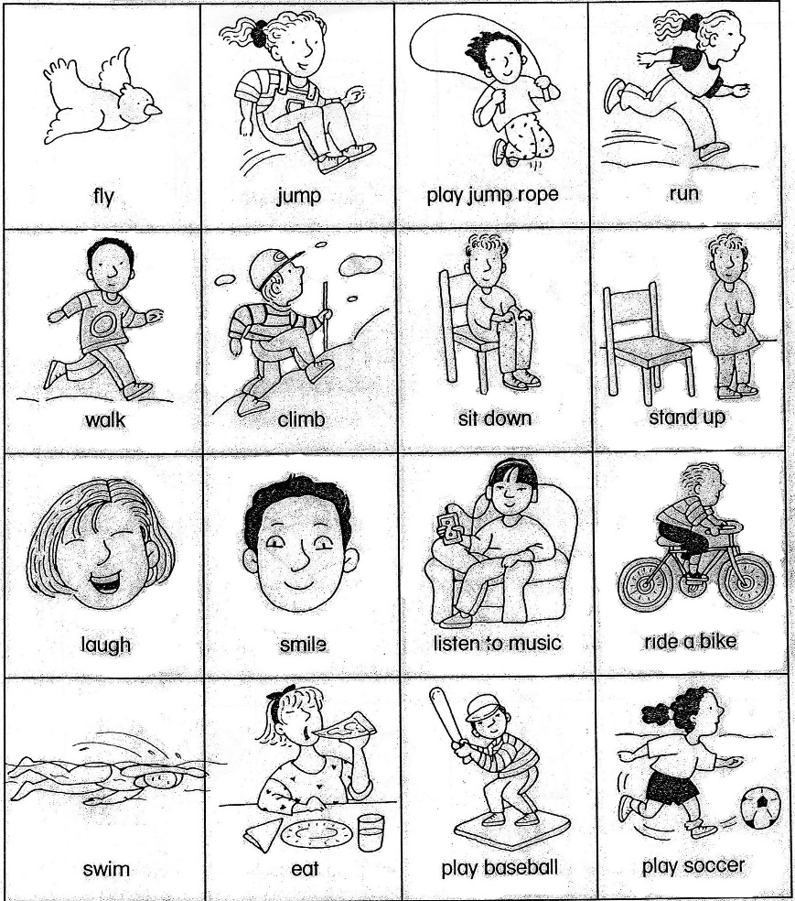 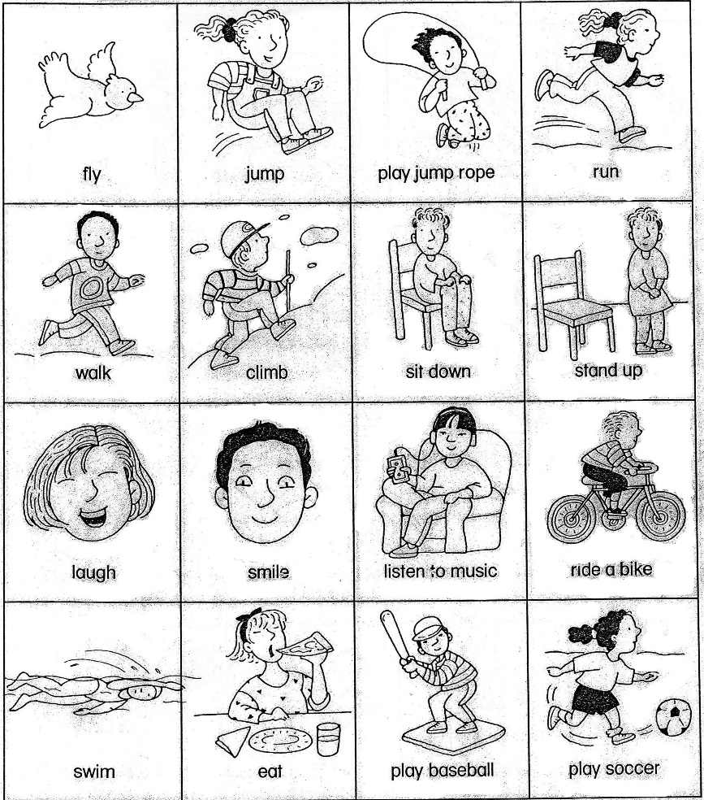 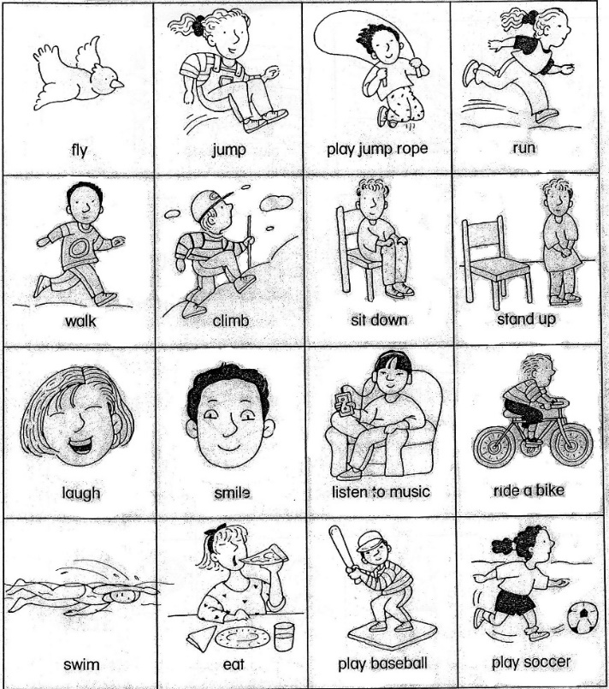

Play cry ride smile talk walk run

Ride laugh swim laugh swim fly play

**II. Complete with: I - YOU - HE - SHE - IT - WE - YOU THEY + *AM - IS - ARE***

__*She_ __is ____* an excellent reader. (Leila) _______ _________ watching TV. ( Alan)

_______ _________ green. ( the dress) _______ _________ on the wall. ( the pictures)

_______ _________ running. ( the cat) _______ _________ playing *Mario Maker.* (Joe and you)

_______ _________ in the garden. ( the roses) _______ _________ driving my car. ( me)

**III. What’s the weather like today?**

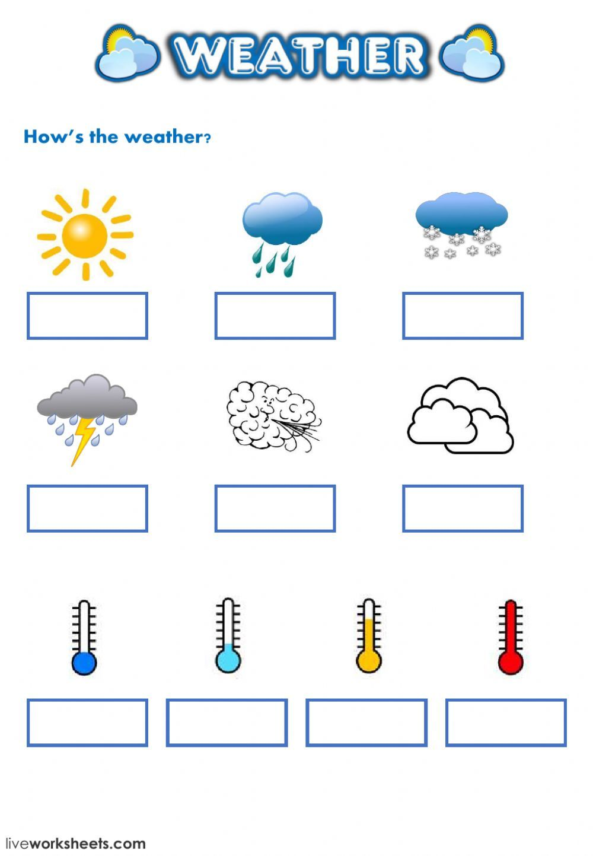  

_____________ _____________ _____________ _____________ _____________

  

_____________ _____________ _____________ _____________ _____________

**NEVER SAY “I CAN’T”. ALWAYS SAY “I’LL TRY”.**